Safety Data Sheet

Helium
Greco Gas, Inc
450 Grantham St.
Tarentum, PA 15084
Tel. 724-226-3800
Fax. 724-226-0332
Info@GrecoGas.com

Section 1: Product and Company Identification
Greco Gas, Inc
450 Grantham St.
Tarentum, PA 15084
Tel. 724-226-3800
Fax. 724-226-0332
Info@GrecoGas.com

Product Code: Helium

Section 2: Hazards Identification
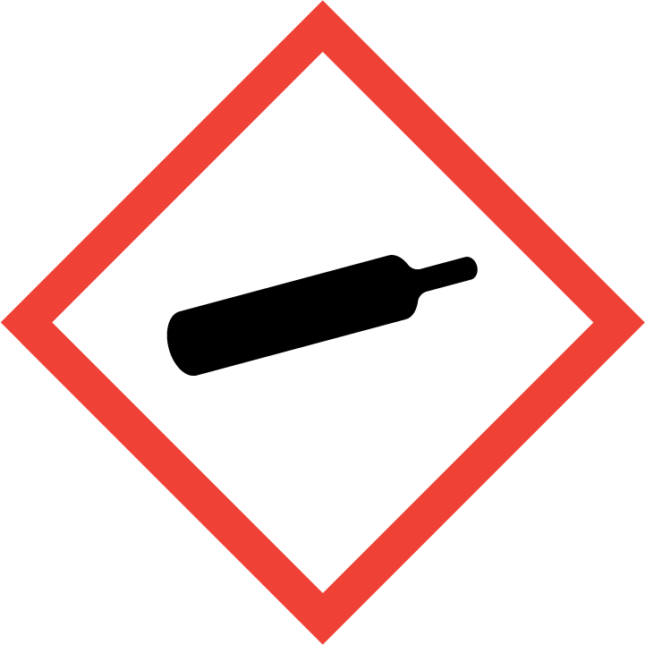
Warning

Hazard Classification:
Gases Under Pressure

Hazard Statements:
Contains gas under pressure; may explode if heated

Precautionary Statements

Storage:
Protect from sunlight.
Store in well-ventilated place.

Asphyxiant in high concentrations

Section 3: Composition/Information on Ingredients

CAS #
7440-59-7

Chemical Substance | Chemical Family | Trade Names
HELIUM | Inorganic gases | HELIUM GAS; HELIUM COMPRESSED; HELIUM-4; ATOMIC HELIUM; UN 1046; He

Section 4: First Aid Measures
Skin Contact | Eye Contact | Ingestion | Inhalation | Note to Physicians
Wash exposed skin with soap and water. | Flush eyes with plenty of water. | If a large amount is swallowed, get medical attention. | If adverse effects occur, remove to uncontaminated area. Give artificial respiration if not breathing. If breathing is difficult, oxygen should be administered by qualified personnel. Get immediate medical attention. | For inhalation, consider oxygen.

Section 5: Fire Fighting Measures
Suitable Extinguishing Media | Products of Combustion | Protection of Firefighters
Non-flammable. Use suitable extinguishing media for surrounding fire. | Non-flammable | - Non-flammable  - Non-flammable

Section 6: Accidental Release Measures
Personal Precautions | Environmental Precautions | Methods for Containment
Keep unnecessary people away, isolate hazard area and deny entry. Stay upwind and keep out of low areas. | Avoid soil, waterways, drains and sewers | Stop leak if possible without personal risk.

Methods for Cleanup | Other Information
Stop leak, evacuate area. Contact emergency personnel. | None

Section 7: Handling and Storage
Handling | Storage
Store and handle in accordance with all current regulations and standards. Subject to storage regulations: U.S. OSHA 29 CFR 1910.101. | Keep separated from incompatible substances.

Section 8: Exposure Controls/Personal Protection
Exposure Guidelines
HELIUM: ACGIH (simple asphyxiant)

Engineering Controls
Handle only in fully enclosed systems.
Eye Protection | Skin Protection | Respiratory Protection
Eye protection not required, but recommended. | Protective clothing is not required. | Non-flammable

General Hygiene considerations
- Avoid breathing vapor or mist
- Avoid contact with eyes and skin
- Wash thoroughly after handling and before eating or drinking

Section 9: Physical and Chemical Properties
Physical State | Appearance | Color | Change in Appearance | Physical Form | Odor | Taste
Gas | Colorless | Colorless | N/A | Gas | Odorless | Tasteless

Flash Point | Flammability | Partition Coefficient | Autoignition Temperature | Upper Explosive Limits | Lower Explosive Limits
Not flammable | Not available | Not available | Nonflammable | Nonflammable | Nonflammable

Boiling Point | Freezing Point | Vapor Pressure | Vapor Density | Specific Gravity | Water Solubility | pH | Odor Threshold | Evaporation Rate | Viscosity
-452 F (-269 C) | -458 F (-272 C) @ 26 atm | 1719 mmHg @ -268 C | 0.138 (Air=1) | Not applicable | 0.94% @ 0 C | Not applicable | Not available | Not applicable | 0.02012 cP @ 26.8 C

Molecular Weight | Molecular Formula | Density | Weight per Gallon | Volatility by Volume | Volatility | Solvent Solubility
4.0026 | He | 0.1785 g/L @ 0 C | Not available | 100% | Not applicable | Insoluble: Not available

Section 10: Stability and Reactivity
Stability | Conditions to Avoid | Incompatible Materials
Stable at normal temperatures and pressure. | Stable at normal temperatures and pressure. | No data available.

Hazardous Decomposition Products | Possibility of Hazardous Reactions
Miscellaneous decomposition products | Will not polymerize.

Section 11: Toxicology Information

Acute Effects
Oral LD50 | Dermal LD50 | Inhalation
Not available | Not available | Nausea, vomiting, difficulty breathing, irregular heartbeat, headache, fatigue, dizziness, disorientation, emotional disturbances, tingling sensation, loss of coordination, suffocation, convulsions, unconsciousness, coma

Eye Irritation | Skin Irritation | Sensitization
Liquid: frostbite, blurred vision | Liquid: frostbite | Difficulty breathing

Chronic Effects
Carcinogenicity | Mutagenicity | Reproductive Effects | Developmental Effects
Not available | Not available | Not available | No data

Section 12: Ecological Information

Fate and Transport
Eco toxicity | Persistence / Degradability | Bioaccumulation / Accumulation | Mobility in Environment
Fish toxicity: Not available  Invertibrate toxicity: Not available  Algal toxicity: Not available  Phyto toxicity: Not available  Other toxicity: Not available | Not available | Not available | Not available

Section 13: Disposal Considerations
Dispose in accordance with all applicable regulations.

Section 14: Transportation Information

U.S. DOT 49 CFR 172.101

Proper Shipping Name | ID Number | Hazard Class or Division | Packing Group | Labeling Requirements | Passenger Aircraft or Railcar Quantity Limitations | Cargo Aircraft Only Quantity Limitations | Additional Shipping Description
Helium, compressed | UN1046 | 2.2 | Not applicable | 2.2 | 75 kg or L | 150 kg | N/A

Canadian Transportation of Dangerous Goods
Shipping Name | UN Number | Class | Packing Group / Risk Group
Helium, compressed | UN1046 | 2.2 | Not applicable

Section 15: Regulatory Information

U.S. Regulations
CERCLA Sections | SARA 355.30 | SARA 355.40
Not regulated. | Not regulated. | Not regulated.

SARA 370.21
Acute | Chronic | Fire | Reactive | Sudden Release
Yes | No | No | No | Yes

SARA 372.65
Not regulated.

OSHA Process Safety
Not regulated.

State Regulations
CA Proposition 65
Not regulated.

Canadian Regulations
WHMIS Classification
A

National Inventory Status
US Inventory (TSCA) | TSCA 12b Export Notification | Canada Inventory (DSL/NDSL)
Listed on inventory. | Not listed. | Not determined.

Section 16: Other Information
NFPA Rating
HEALTH=0 FIRE=0 REACTIVITY=0 SPECIAL=SA
0 = minimal hazard, 1 = slight hazard, 2 = moderate hazard, 3 = severe hazard, 4 = extreme hazard

